Questionnaire – Staff

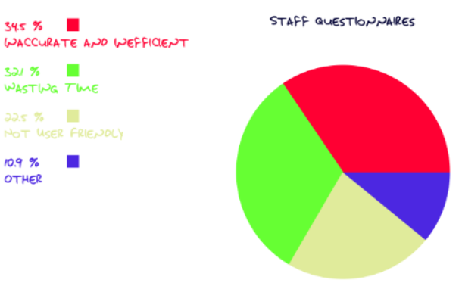

Questionnaires are given out to a total of 50 librarian of National Library of Malaysia to collect their responses toward the current old library management system. Based on the pie chart above, it shows that most of the librarian (34.5) agreed that the current system which does not efficient and inaccurate. For example, when librarian need to statistic the book in library they need to count the book one by one.

Besides that, 32.1% of librarians are unsatisfied with the current system which takes up lots of time to process the borrowing system. This is because when library' s members want to borrow some book they need to chop the due date on the book on that book and record the members information.

Moreover ,22.5% of the librarians agreed that the current system is not user friendly. This is because the current system requires too many manual procedure.